

Tut Sadeh Folkore Dance Company

Ramat Hasharon, Israel

Tut Sadeh Folklore Dance Company was founded by artistic director and choreographer Ran Hirsch, in the city of Ramat Hasharon, Israel in 2002. The company operates under the cover of Migvanim recreational center in the city of Ramat Hasharon, and is managed by Sigal Rabin.

The company consists of 30 male and female dancers between the ages of 30 and 60. All the dancers have background and experience in the field of folk dancing, and some have Ballet and Modern dance experience as well.

Our repertoire is comprised of dances from various folklore styles, such as Israeli folklore, Ladino (Spanish) Folklore. The dances are dances in various choreographic structures such as circles, rows and mainly couples.

The company participates in major dance festivals throughout the country: Jerusalem Folklore Dance Festival, Karmiel Dance Festival. During these festivals we dance and perform, and spend a lot of time together as a group, putting an emphasis on the social aspect as well as the professional.

The company dances to Israeli music of different styles. From songs that were written 66 years ago when Israel was just founded to more contemporary songs performed by leading singers today. The dances may be of one song, or a medley comprised of several songs. The dances depict the Israeli culture or way of life and the Jewish spirit and holidays.

Let's Dance! (Hava Netze BeMachol) is a classic Israeli Hora dance. The music is a medley of songs that were written and composed during Israel's early years as an independent country. The choreography combines known Israeli Folk dances that were choreographed during those same years with Hirsch's personal touch and choreography.

Song of Hope (Shir Tikva) is a more recent dance in the company's repertoire and was choreographed 2 years ago. The song, too, is modern and is performed by two leading Israeli singers. The choreography is more contemporary, yet combines classic folklore style and reflects the song's message of believing in one's self and not giving up or losing hope even if you don't achieve your goals today, there is still tomorrow or even next year.

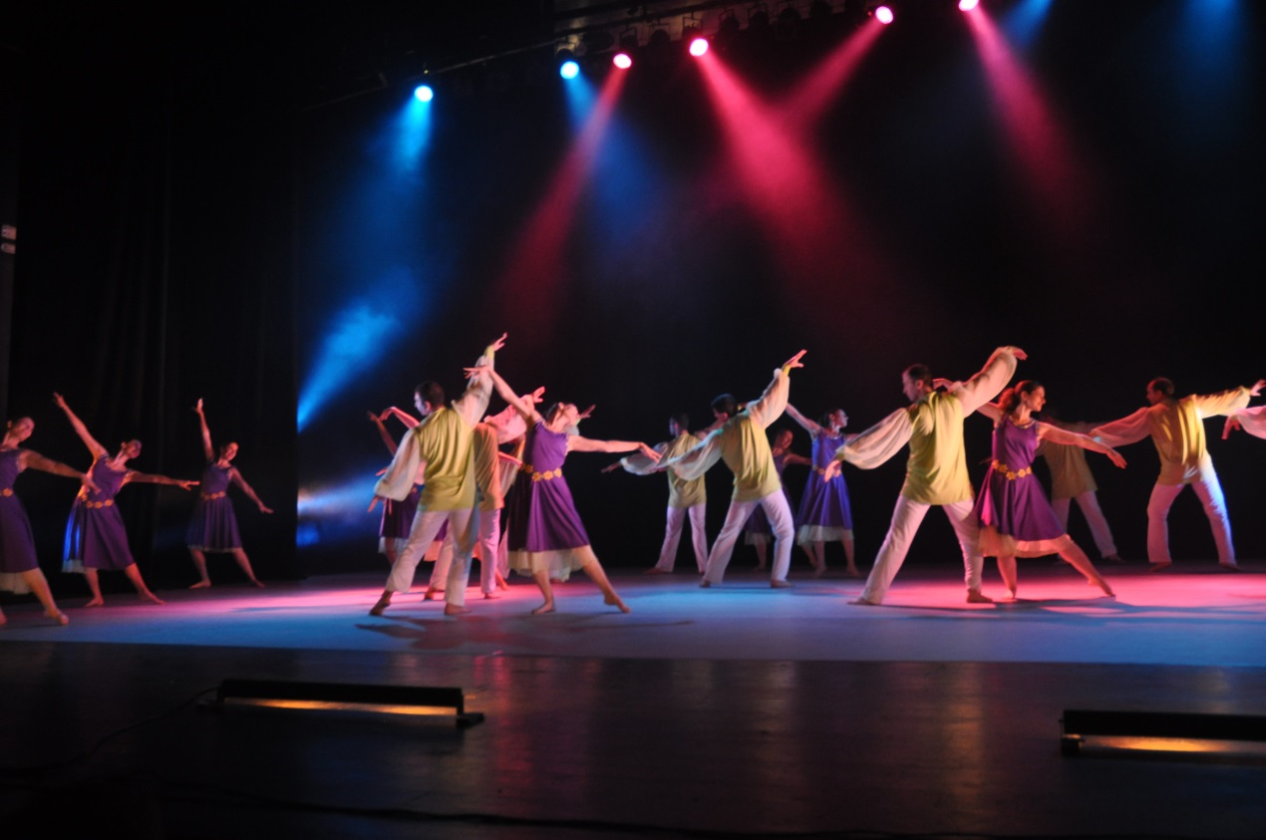The Lilac Flower (Perach HaLilach) is a song about the strong love between a man and a woman, who don't want the day to end or for the fall to arrive, so that this moment, their moment, will last forever. Accordingly this dance is choreographed entirely in couples, dancing closely, and holding on to each other for as long as they can.

The Lilac Flower, 15.6.2013, Drom Hasharon Dance Festival.

Rosa is a song from the musical Kazablan. This musical, which was written in 1954, deals with the burning social issues that existed in the 1950's and are relevant till this very day concerning the Israeli society. These issues regard the relations between the Ashkenazi and Sephardic ethnicities that live together in this country, nationality and loyalty towards the country, equal rights for each of the ethnic groups, prejudice and accepting who is different than you, etc.